You can help your baby’s brain development
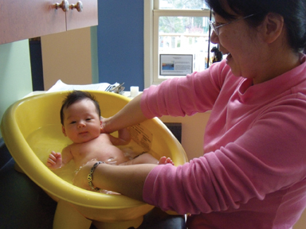
(NC)—A new website has been launched to help parents build their baby’s brain.

This may seem like an intriguing construction project but really, it is all about child development. Louise Choquette, from the Best Start Resource Centre, explains:

“We surveyed parents of young children and they told us they knew that the early years were critical and have an impact for the rest of the child’s life. What was stressing out parents, however, was that they were unsure of what to do to help regarding brain development during those first few years. They wanted to know what foods to give their baby and what toys were best for brain development. In some cases, they were not sure whether they needed to use flash cards and videos to have smart kids.”

Brain development has an impact on all areas of child development, including physical health and well-being.

This fact prompted Health Nexus – a not-for-profit organization specializing in health promotion and the home of the Best Start Resource Centre – to develop the www.HealthyBabyHealthyBrain.ca website, a how-to resource for parents. The site hosts 15 short videos on topics such as nutrition, sleep, play, literacy, physical activity, attachment, self-regulation, discipline, stress, and more. This online resource is intended for future parents and for parents of children aged zero to three.

The videos show real-life situations that were filmed with families from Ontario. In some of the videos, experts comment on the parent-child interactions and offer practical suggestions based on proven practices. All the videos can be shared through online social networks. The website also contains links to other useful resources.

As Choquette points out, parents of young children don’t have much time and the survey results indicated that they like to learn about parenting using interactive websites. The videos encourage viewers to interact often with their babies in a positive way, and demonstrate how it can be done. Parents who tested the site found it to be very informative and had comments such as this one: “I loved the website… I wish it had been around 3 years ago when I had my first baby.”

In addition to being available at www.HealthyBabyHealthyBrain.ca, the videos will also be used in parent workshops offered through Ontario Early Years Centres. This will reinforce the messages to parents that all of the little things they do every day with their baby impacts on their development.
www.newscanada.com

Word count: 405

Website guides parents on baby brain development

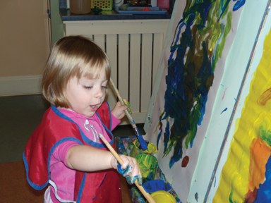
(NC)— Do you ask: What should I feed my baby to build a healthy brain? Or: Should I let my baby cry if I am sure there is nothing wrong with him?

These are some of the questions from parents who were recently surveyed on early brain development awareness. Parents know that the early years are critical but don’t always know what to do. They receive many messages through advertising, books, family members and friends and are sometimes confused.

This information prompted the Best Start Resource Centre to develop a website for parents of children aged zero to three. The new site www.HealthyBabyHealthyBrain.ca, hosts a series of short videos on topics such as nutrition, sleep, play, literacy, physical activity, attachment, self-regulation, discipline, stress, etc. It also contains information for expecting parents because the prenatal period is so important for brain development.

The videos show real-life situations that were filmed with families from Ontario. They provide examples of how to interact effectively with your child. They also offer useful expert commentary to help parents understand the situations from the children’s perspective.

The reaction to the website by viewers has been very positive. Parents say they appreciate the fact that it is very user-friendly and does not preach at them. Some comments received include: “It was great to have all the information in one place.” “I wish all parents would see these videos.”

Over the next few months, the goal of the Best Start Resource Centre is to reach a large number of parents by promoting the website through parent programs and healthcare providers.
www.newscanada.com

Word count: 269

Website launched to inform parents about brain development

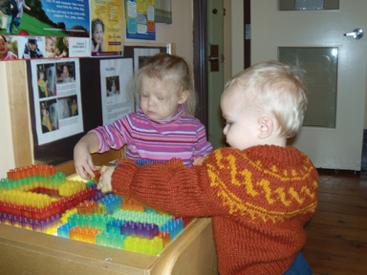
(NC)—The Best Start Resource Centre has launched the website, www.HealthyBabyHealthyBrain.ca. It provides information to parents (and expectant parents) on the brain development of children aged zero to three. According to Louise Choquette, who coordinated the project, parents are sometimes unsure of what to do to support their baby’s brain development. They have a lot of questions including what foods to give them and what toys to give them.

The website hosts a series of short videos on topics related to brain development, such as nutrition, sleep, play, literacy, physical activity, attachment, self-regulation, discipline, and stress. Choquette says what stands out the most in these videos is the importance of the relationship between the parent and the baby. The way a parent interacts with their child can affect the brain in ways that are not always obvious.

The videos provide real-life examples of how to interact effectively with young children. There is also some expert commentary that helps parents understand situations from a child’s perspective. Because the videos are short (about 2 to 6 minutes each) the website is useful to parents of young children who typically don’t have much time but want to learn about parenting.

Parents and service providers who viewed the videos indicated that they are anxious to share this website with their friends. They will have the opportunity to easily share the videos through their social media networks.
www.newscanada.com

Word count: 240

